Name – Manav Sharma
Student Number – R00183839

Question1

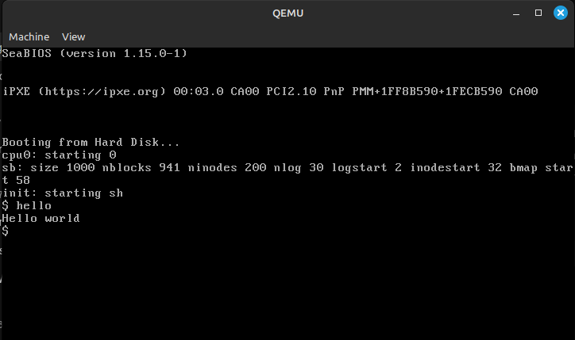

Question 2

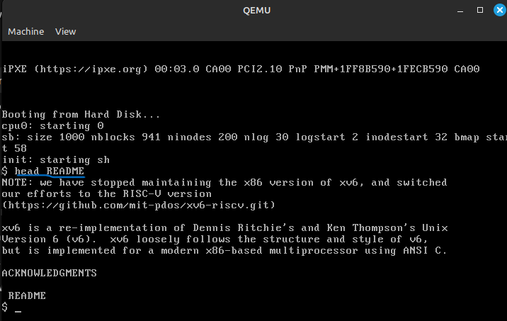

Question 4

In xv6, the management of interrupts and system calls involves several key components and mechanisms. Below is a brief description of how xv6 handles interrupts and system calls:

Interrupts:

xv6 distinguishes between interrupts (hardware-generated events) and traps (software or exceptional events). The system uses a common mechanism for handling both interrupts and system calls, as they share similar code paths. The IDT is initialized during system boot, with each entry corresponding to a specific interrupt or trap. xv6 uses vector.S to define interrupt vectors and trapasm.S to set up the interrupt and trap handlers.

xv6 uses interrupt gates for hardware interrupts and trap gates for software exceptions and system calls. System calls and exceptions go through the same code path, allowing for a unified handling mechanism.

xv6 is designed for multiprocessor boards and uses both the local APIC and IO APIC for interrupt handling. IO APIC is programmed to map interrupts to processors and devices. The local APIC handles timer interrupts independently for each processor.

Timer interrupts, for example, are set up in idtinit, configuring vector 32 to handle IRQ 0. The timer is programmed to generate interrupts periodically (e.g., 100 times per second) for tasks like time tracking and process time-slicing. The scheduler on each processor enables interrupts to allow the processor to receive and handle interrupts. Certain critical code sections explicitly disable interrupts to prevent interruptions during specific operations.

System Calls:

System calls are triggered through the int instruction, generating a trap. The IDT is used to map the trap to the appropriate handler.

When a trap occurs, a trap frame is constructed, containing the processor registers at the time of the trap. The trap frame is used to store information about the interrupted process, allowing the system to resume execution after handling the trap.

The trap handler invokes the syscall function, which extracts the system call number from the trap frame. The system call number is then used to index into the system call table to identify the corresponding system call function.

Helper functions (argint, argptr, argstr, and argfd) are employed to retrieve system call arguments from user memory. These functions ensure the validity of user-space pointers and prevent unauthorized access to memory.

The return value of the system call function is recorded in the %eax register, following the convention of negative values for errors and positive values for success. The trap frame facilitates the return of control to user space with the updated register values.

Question 6

In the given scenario, the attacker aims to dump all the contents of HTTP requests to/from a web server by inspecting read and write system calls. The attacker intends to use Linux tools such as strace and bcc to achieve this.

Overview of the Attack:

Identifying the Web Server Process:

The attacker starts by identifying the process ID (PID) of the web server. In the provided example, the attacker uses the ps command “ps -ale | grep node”
to list all processes and filter for the web server process, assuming it's a Node.js-based server. The attacker identifies the PID of the web server, let's say it's 4563.

Dumping System Calls with strace:

The attacker uses strace (sudo strace -p 4563) to trace system calls of the identified web server process (PID 4563 in this case).
Although, the basic strace command only dumps the first 20 bytes of the read/write requests, providing a limited view of the data.

To capture the complete request/response message contents, the attacker needs to refine the methodology.

Using bcc for Enhanced Tracing:

The attacker can leverage bcc (BPF Compiler Collection) tools for more advanced tracing capabilities.
BPF (Berkeley Packet Filter) is a powerful framework for monitoring and manipulating network traffic.
Specifically, the attacker may use tools like tcpconnect or trace from bcc to trace network activity in more detail.

Example: Using tcptracer to Dump HTTP Headers:

The attacker could use a tool like tcptracer to trace TCP connections and dump the contents with command like this sudo tcptracer -p 4563 -T -D

The -T flag ensures that the tool decodes and prints out TCP payloads, potentially including HTTP headers. The -D flag provides a more detailed output.

Analyzing HTTP Headers and Contents:

With the refined methodology and advanced tracing tools, the attacker can analyze the complete HTTP headers and request/response contents.
The attacker may need to interpret the binary data or employ additional tools to convert it into human-readable format.

